Integrated Business Intelligence and Machine Learning Approach for E-Commerce Sales Forecasting

By
Biliaminu Ishola 472117942
Md. Shakil Hossain 472118102
Ajmal Hamidi 472117941

To
Dr. Mona Alsaleem



Information Technology Department
College of Computer
Qassim University
Kingdom of Saudi Arabia (KSA)
Table of Contents
CHAPTER I INTRODUCTION 4
1.1. Background and Context of Business Intelligence 4
1.2. The Synergy between BI and Machine Learning 4
1.3. Core Definitions 4
1.4. Problem Statement 5
1.5. Proposed Idea and Scope 5
1.6. Project Objectives 6
1.7. Research Questions (RQ) 6
1.8. Importance of the Study 7
1.9 Limitations of the Study 7
CHAPTER II LITERATURE REVIEW 8
2.1 Introduction 8
2.2 Traditional Forecasting Methods in E-Commerce 8
2.3 Machine Learning Approaches to Sales Forecasting 9
2.4 Business Intelligence Frameworks for E-Commerce 11
2.5 Integration of Business Intelligence and Machine Learning 11
2.6 Feature Engineering and Data Preparation 12
2.7 Evaluation Frameworks and Metrics 13
CHAPTER III METHODOLOGY 14
3.1 Introduction 14
3.2 Research Design 14
3.3 Data Source and Collection 14
3.4 ETL Process within a Business Intelligence Framework 14
3.5 Data Warehouse Design 16
3.6 Feature Engineering 17
3.7 Machine Learning Model Development 18
3.8 Model Training Procedure 18
3.9 Model Evaluation Metrics 19
3.10 Dashboard Integration 19
3.11 Tools and Technologies 19
3.12 Summary 20
CHAPTER IV RESULTS 21
4.1 Weekly Sales Trend 21
4.2 Linear Regression Model Performance 21
4.3 Random Forest Model Performance 22
4.4 XGBoost Model Performance 23
4.5 Model Performance Comparison 24
4.6 Interpretation 24
CHAPTER V CONCLUSION 26
5.1 Future Work 26
5.1 Conclusion 26
References 28

CHAPTER I

INTRODUCTION

1.1. Background and Context of Business Intelligence
In the contemporary era of digitalization, organizations are inundated with massive volumes of data generated from various touchpoints, especially within the e-commerce sector. Business Intelligence (BI) has emerged as a crucial discipline that enables organizations to collect, process, and analyze this data to support strategic decision-making. Historically, BI was primarily focused on descriptive analytics—providing answers to the question, "What has happened?" This involved the use of data warehousing, OLAP (Online Analytical Processing), and reporting tools to visualize historical performance [1].
However, as the market environment becomes increasingly volatile and competitive, relying solely on historical data is no longer sufficient for survival. The e-commerce industry, characterized by rapid changes in consumer behavior, seasonal fluctuations, and intense promotional cycles, requires a move toward more proactive strategies.

1.2. The Synergy between BI and Machine Learning
The core of this research lies in the synergy between descriptive and predictive analytics. While traditional BI provides the foundation by organizing and cleaning historical data, Machine Learning (ML) adds a layer of intelligence by identifying hidden patterns and predicting future outcomes. This integration transforms BI from a static reporting tool into a dynamic system capable of forecasting "What will happen?" [2].
In the context of e-commerce sales forecasting, this synergy allows businesses to transition from "Reactive Insights" (reacting to a drop in sales after it occurs) to "Proactive Insights" (anticipating demand and adjusting inventory or marketing strategies beforehand).

1.3. Core Definitions
To clarify the scope of this integrated approach, we establish the following definitions based on our project framework:
Business Intelligence (BI): A set of strategies and technologies used by enterprises for the data analysis of business information. It provides historical, current, and predictive views of business operations.
Data Mining and Machine Learning: The process of discovering patterns in large data sets involving methods at the intersection of machine learning, statistics, and database systems. In this project, these techniques are used to build predictive models for future sales.

1.4. Problem Statement
The motivation for this study stems from several critical limitations found in traditional forecasting methods used by e-commerce retailers. Despite the advancement in BI tools, many organizations still struggle with the following issues (as highlighted in our proposed framework):
Siloed Data Sources: Transactional data, customer feedback, and marketing logs are often stored in disparate systems, preventing a holistic view of the factors driving sales.
Lagging Indicators Only: Most traditional retail reports focus on historical performance without the capability to project future trends accurately, leading to missed opportunities.
Inability to Handle Non-linear Patterns: Sales data is rarely linear. Traditional statistical models often fail to capture the complex, non-linear relationships caused by sudden market shifts or changing consumer preferences.
Poor Accuracy During Promotions: One of the biggest challenges in e-commerce is predicting the surge in demand during "Black Friday" or other promotional campaigns. Conventional methods often significantly under- or over-estimate these peaks.
Lack of Real-time Adjustments: Without an integrated ML-BI pipeline, businesses cannot adjust their forecasts in real-time as new transactional data flows into the system.
Failure to address these problems leads to inefficient inventory management, resulting in either "stock-outs" (lost revenue) or "overstocking" (increased holding costs and potential waste).

1.5. Proposed Idea and Scope
This project proposes an integrated BI-ML framework designed to optimize e-commerce sales forecasting. The proposed idea utilizes the UCI Online Retail Dataset to train advanced machine learning algorithms (such as Random Forest and XGBoost) and integrate their outputs into a comprehensive BI dashboard.
The scope of this integration covers:
- Analyzing historical sales patterns and seasonality.
- Identifying the impact of temporal factors (holidays, weekends).
- Evaluating the influence of marketing activities and external variables.
- Providing a visualization layer for decision-makers to interpret model results easily.

1.6. Project Objectives
The primary aim of this research is to bridge the gap between complex data mining techniques and practical business decision-making. The specific objectives are as follows:
Framework Development: To develop an integrated BI-ML framework specifically tailored for the e-commerce sales environment.
Evaluate Models: To evaluate the performance of modern ML algorithms against traditional forecasting methods to determine the improvement in accuracy.
Identify Key Drivers: To identify the most influential factors (features) that drive sales using real-world transactional data.
Enhance Decision-Making: To create a system where AI-driven insights are presented in a way that non-technical managers can use to make strategic decisions.

1.7. Research Questions (RQ)
To guide the investigation, this paper addresses the following research questions:
RQ1: How does BI-ML integration enhance forecasting accuracy? We investigate whether combining structured BI data with ML algorithms significantly reduces the Mean Absolute Error (MAE) compared to baseline models.
RQ2: Which data features impact sales predictions most? We analyze which variables such as unit price, quantity, country, or temporal factors hold the highest predictive power.
RQ3: Which ML models perform best in a BI environment? A comparative analysis of Random Forest, XGBoost, and Linear models to identify the most robust algorithm for this use case.
RQ4: How does integration improve decision-making for managers? We explore the qualitative benefits of having predictive insights integrated directly into a BI dashboard for ease of interpretability.

1.8. Importance of the Study
The significance of this study lies in its practical application for the Information Technology and Business sectors. By providing a clear roadmap for integrating ML into BI pipelines, this research helps organizations maximize the ROI of their data assets. For e-commerce managers, the findings provide a method to stabilize supply chains and optimize marketing budgets through more reliable demand forecasting.

1.9 Limitations of the Study
While the results are encouraging, there are a few limitations worth noting.

First, the dataset used is relatively limited, which may affect how well the model performs when applied to larger or more diverse data. Second, weekly sales data tends to be quite volatile, meaning it can fluctuate due to factors that are not captured in the dataset. This can make predictions less stable in some cases.

Another limitation is that the current system focuses on evaluating predictions using historical data rather than forecasting completely unseen future weeks. In addition, external factors such as holidays, promotions, and economic conditions were not included, even though they can significantly influence sales patterns.

CHAPTER II

LITERATURE REVIEW

2.1 Introduction
The integration of Business Intelligence (BI) and Machine Learning (ML) for e-commerce sales forecasting represents a convergence of two traditionally distinct paradigms: descriptive analytics and predictive analytics. This literature review examines the theoretical foundations, methodological developments, and empirical findings that inform the development of an integrated BI-ML approach for e-commerce sales forecasting. The review is organized into five thematic sections: (1) traditional forecasting methods and their limitations, (2) machine learning applications in sales forecasting, (3) business intelligence frameworks for e-commerce, (4) integration strategies for BI and ML systems, and (5) evaluation frameworks and performance metrics.

2.2 Traditional Forecasting Methods in E-Commerce
Conventional forecasting techniques have extensively been based on statistical time series models which make the assumptions of underlying patterns including trend, seasonality and cyclical components. Box et al. [3] set the strand of the Autoregressive Integrated Moving Average (ARIMA) models that are currently used extensively in sales forecasting. These models work on the premise that past trends can be projected into the future through the formation of autocorrection formations in the data.
In the case of e-commerce applications, Hyndman and Athanasopoulos [4] adapted the conventional time series methods to the special features of retail data such as several seasonality trends and the intermittent demand. The authors presented the Exponential Smoothing State Space Model (ETS) framework that offers a coherent mechanism of addressing trend and seasonality elements without compromising on interpretability that is a vital constraint of business stakeholders.
Nevertheless, the shortcomings of the classical statistical procedures when applied to e-commerce have been widely reported. The M3 and M4 forecasting competitions by Makridakis et al. [5] showed that there is no universal statistical method that performs better than others in different datasets. More importantly, these competitions unveiled that the more traditional approaches fail to work with datasets that have high volatility, promotional interventions, and non-linear relationships which are all attributes of e-commerce sales data.
Application of the old-fashioned forecasting techniques in e-commerce is fraught with a number of particular issues that are detected in literature. According to Chen and Chen [6], the data of e-commerce has three properties that do not align with the assumptions of a classical time series model: (1) non-stationarity due to external factors (such as marketing campaigns), (2) a high dimensionality (tens of thousands) due to the presence of thousands of SKUs (Stock Keeping Units), and (3) intermittent demand patterns whereby most of the products have their demand equal to zero.
Moreover, as shown by Pavlyshenko [7], the definition of the traditional models does not bring exogenous variables to the fore. Although ARIMA with exogenous inputs (ARIMAX) theoretically allows the addition of external factors, the linearity assumption makes it incapable of producing any complex interaction between variables, including price fluctuations, competitor behaviors, and customer moods. The paper found that under the conditions of the conditions of the e-commerce platforms with dynamic pricing and frequent promotions, the traditional statistical models make forecast errors more than 30% in the period of the peaks.

2.3 Machine Learning Approaches to Sales Forecasting
XGBoost (Extreme Gradient Boosting) proposed by Chen and Guestrin [8] has now become one of the landmark algorithms when it comes to sales forecasting tasks. The algorithm uses gradient boosting framework with regularization to avoid overfitting, which is an important factor when using high-dimensional e-commerce data. The authors proved that XGBoost is always better in structured problems of data when compared to the traditional methods and is more accurate but computationally efficient.
These findings have been confirmed by comparative studies in e-commerce situations. Pavlyshenko [7] compared several machine learning algorithms such as XGBoost, Random Forest, and neural networks with the ARIMA models based on the data of an online retailer. The research discovered that XGBoost minimized the forecasting error by 23.2 percent on average over ARIMA and the effects were more significant during promotional events. It was found that the algorithms had the capability of automatically taking into account the interaction effect of features like the combined effect of discount percentage and product category, as one of the modes of superior performance.
Another improvement was introduced by LightGBM that was proposed by Ke et al. [9], which employed the use of gradient-based one-sided sampling and exclusive feature bundling. Such innovations allow reducing training time without loss or degradation in accuracy, and thus the algorithm can be used especially well in the e-commerce application, where one needs frequent model retraining. The fact that the categorical features are processed by the algorithm without the need to encode them as one-hot is also a simplification in terms of integrating it with the BI systems that tend to store categorical data like product categories and customer segments.
S. S. R. K. T. V. S. Kiran [10] used LSTM networks to SKU-level e-commerce forecasting and also stated that it outperformed ARIMA and feed-forward neural networks. Nevertheless, the author observed that LSTM models take considerable amounts of training data and computational resources and can be a challenge when it comes to deploying smaller e-commerce processes.
Attention-based architectures have also recently shown state of the art performance in time series forecasting. The Transformer architecture, presented by Vaswani et al. [11] instead of recurrent connections substitutes them with self-attention mechanisms. To do sales forecasting Wu et al. [12] suggested the Informer model, which is quadratically simple, but offers long-sequence forecasting. These architectures provide the chance to represent short-term fluctuations and long-term dependencies at the same time.
Bontempi et al. [13] came up with an algorithm form of integrating ARIMA and neural networks, with ARIMA representing the linear aspects and neural networks representing the non-linear trends in the residues. The experimental analysis of e-commerce data proved that this hybrid model can reduce the error rates compared to either technique. The modular architecture of the framework is also compatible with integrated BI-ML systems in which various components may be processed using distinct data streams.
On the same note, Bandara et al. [14] presented a hybrid method that uses exponential smoothing and LSTM networks. The research established that exponential smoothing of the data to remove trend and seasonality was a significant performance enhancement of LSTM since this step enabled the neural network to concentrate on the more valuable non-linear association as opposed to underpinning temporal trends.

2.4 Business Intelligence Frameworks for E-Commerce
Any BI system is based on the data architecture. Kimball and Ross [15] made the dimensional modeling approach the overall paradigm in the data warehousing. The star schema, which is made of fact tables which hold the quantitative values and dimension tables which hold the descriptive information, gives the business users an intuitive design but the query performance is achieved efficiently.
In the case of e-commerce applications, there have arisen certain dimensional modeling patterns. The table of facts identified by Golfarelli and Rizzi [16] are sales transactions, movements and interacts with customers, and these dimensions are in turn divided into time, product, customer and channel. The authors have stressed that a properly built data warehouse is not just used to conduct reporting but also to provide an uncontaminated and coherent dataset to train the ML model which is considered a vital factor of integrated BI-ML systems.
The most common interface of business stakeholders with BI systems is descriptive analytics, which is implemented using interactive dashboards. The design principles of effective dashboards were developed by Few et al. [17], since it is necessary to pay attention to such aspects of a good dashboard as visual hierarchy, contextual information, and actionable metrics. In the case of sales forecasting applications, dashboards should not only show the values of the forecasts but also the uncertainty range and factors that contributes to making appropriate decisions.

2.5 Integration of Business Intelligence and Machine Learning
BI and ML systems integration have both technical and organizational challenges. The systematic literature review by Popovic et al. [18] into the business intelligence and analytics domain revealed that the gap between the descriptive and predictive analytics in the aspects of integration was one of the issues that remained constant. The authors suggested a maturity model in which organizations move to individual BI and ML implementations to combined systems with predictions entrenched in the BI dashboards and BI insights guiding the creation of features to the ML models.
Apache Spark is a comprehensive engine of big data processing that is proposed by Zaharia et al. [19] and can be used to execute both BI workloads and ML workloads. This integrated architecture makes it easier to maintain a separate pipeline of reporting and modeling and therefore organizations have the capability of implementing integrated systems in a more cost-effective way. In the case of e-commerce applications, the fact that it is able to make use of streaming data to generate real-time features is an enormous plus.
The essential complication in the implementation of ML alongside BI is the black box character of intricate models. Barredo Arrieta et al. [20] presented a taxonomy of explainable artificial intelligence (XAI) techniques in detail, differentiating between methods of intrinsically interpretable models and post-hoc explanation methods. In the case of BI dashboards that are required to assist in business decision-making, the authors highlighted that the explanations should be given in accordance with the technical capabilities of the stakeholder.
Lundberg and Lee [21] came up with SHAP (SHapley Additive exPlanations), a single framework of interpreting model predictions in terms of cooperative game theory. SHAP values break down predictions into feature contributions, which present consistent explanations that can be represented in BI dashboards. In the case of sales forecasting, SHAP explanations can determine whether a decrease in a forecast is caused by seasonality, price variation, or external variables that allow stakeholders to make the right decisions.
Sculley et al. [22] pointed at the concept of the hidden technical debt of machine learning systems and suggested that the ML algorithm comprises of a very small part of the overall complexity of the system. The authors named data validation, feature management, and model monitoring as the most important elements that are frequently overlooked in research-oriented ML projects. In case of integrated BI-ML systems, these factors are further enhanced by the requirement to ensure compatibility with particular BI infrastructure present.
Kreuzberger et al. [23] offered a systemic overview of MLOps practices, with continuous integration, continuous deployment, and continuous monitoring as the key capabilities of production ML systems. In the e-commerce forecasting case, MLOps can be used to perform automated retraining of models in reaction to data drift, which is a natural phenomenon as the market conditions and customer behavior change. MLOps and BI dashboard integration allow notifying stakeholders about the need to retrench models and their bad performance.

2.6 Feature Engineering and Data Preparation
Input features are very crucial to the functionality of ML models. Dawson [24] has shown that marketing mix variables are important in e-commerce forecasting by demonstrating that the model that uses advertising expenditure, social media interaction, and email campaign measurements have a great impact in comparison to models that are based on past history sales only. The paper has pointed out that these marketing metrics are normally handled in BI systems, which explains the importance of integration.

2.7 Evaluation Frameworks and Metrics
Makridakis et al. [25] highlighted that it is not possible to measure all the factors of forecast quality using a single metric. The authors suggested the consideration of forecasts in terms of several complementary aspects: RMSE to penalize big errors, MAE to comprehend the average magnitude of errors, and sMAPE to compare across the products with various sales volumes.
In addition to the statistical accuracy, it is important to determine the business value of improving the forecasting. The inventory cost framework was developed by Chopra and Meindl [26] and it shows that the accuracy of the forecast has a direct proportional relation to the levels of safety stock and service rates. The authors demonstrated how a 10% decrease in the forecast error will help decrease the total inventory costs by 15-20 percent in the form of decreased safety stock and decreased stockouts.
In the case of e-commerce applications, inventory is not the only area that incurs expenses related to forecasting errors. Boone et al. [27] studied the effects of errors in the forecasts on customer satisfaction and concluded that stockouts during the peak season led to irreparable customer churn rates of more than 20 percent in case of high-value customer groups. These results emphasize the business importance of enhancing the accuracy of the forecasts by using the integrated BI-ML models.

CHAPTER III

METHODOLOGY

3.1 Introduction
This chapter presents the methodology adopted for the design and implementation of the weekly sales prediction system. The methodology integrates data engineering, data warehousing, machine learning, and business intelligence techniques to develop an intelligent system capable of predicting future weekly sales. The methodology ensures that raw transactional data is transformed into structured, meaningful, and predictive information. The process includes data extraction, data cleaning, transformation, warehouse design, feature engineering, machine learning model development, evaluation, and dashboard integration. This structured methodology ensures reliability, scalability, and accuracy of the prediction system.

3.2 Research Design
This research adopts an experimental and system development approach. The experimental approach allows different machine learning models to be trained and evaluated to determine the best-performing model. The system development approach involves building a complete pipeline consisting of ETL, data warehouse, predictive model, and dashboard visualization. This approach ensures the system can operate as a real-world business intelligence and predictive analytics solution.

3.3 Data Source and Collection
The dataset used in this research is the Online Retail dataset containing transactional records of an online retail store. The dataset contains attributes including Invoice Number, Product Code, Description, Quantity, Invoice Date, Unit Price, Customer ID, and Country. These attributes provide sufficient information to analyze sales trends, customer behavior, and product performance. The dataset represents real-world retail operations and provides a suitable foundation for predictive modeling.

3.4 ETL Process within a Business Intelligence Framework
The Extract, Transform, and Load (ETL) process represents a core component of the business intelligence framework adopted in this study. ETL provides the structured pathway through which raw transactional records from the Online Retail dataset are converted into analytically useful and decision-supportive information [30]. This aligns with standard BI principles, which emphasize systematic data collection, organization, and transformation as prerequisites for meaningful analysis and insight generation. [33]
During the Extract phase, raw data is retrieved from the source dataset and imported into the Python environment using the Pandas library. This stage ensures that transactional records: including invoice details, product attributes, quantities, prices, and customer identifiers, are made accessible for subsequent processing.
The Transform phase encompasses several data preparation tasks that are essential for both business intelligence and predictive modeling. These include the removal of missing values, duplicate entries, and invalid or inconsistent records, as well as the correction of data types to ensure structural integrity. Additional derived variables, such as Revenue (computed as Quantity × Unit Price), are generated to enrich the analytical depth of the dataset. This transformation process not only enhances data quality but also enables the identification of trends, relationships, and patterns (central objectives of BI analytics).
The transformational component also implicitly incorporates BI-related activities such as data mining and data interpretation. Data mining techniques facilitate the extraction of previously hidden patterns and insights from the cleaned dataset, while interpretation ensures that these findings are contextualized in relation to real-world business operations [33]. Together, these functions enable the dataset to serve not merely as a record of past transactions but as a foundation for meaningful insight generation and predictive modeling.
In the Load phase, the cleaned and enriched data is organized into structured tables and stored in CSV format. These tables serve as the foundation for downstream processes including data warehousing, machine learning model training, and dashboard visualization. By completing the ETL cycle, the methodology ensures that raw data is systematically converted into reliable, interpretable, and analysis-ready information, consistent with the principles and objectives of business intelligence systems [30].

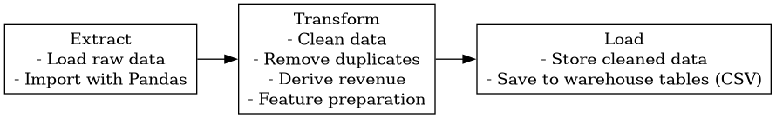
Fig 3.4.1 illustrates the ETL workflow used in this study

3.5 Data Warehouse Design
The data warehouse for this study was designed using a fact-based star schema to support efficient analytical processing and predictive modeling. The schema organizes the cleaned and transformed dataset into a central fact table surrounded by dimension tables that provide contextual attributes [30]. This structure enhances query performance, reduces redundancy, and aligns with established data warehousing principles used in business intelligence systems.
The central Fact Weekly Sales table stores aggregated weekly sales metrics, including Total Weekly Sales, Transaction Count, Customer Count, Quantity Sold, and the number of Unique Products Sold. Additional derived measures such as Average Order Value and Average Quantity per Transaction were included to enrich the analytical depth of the warehouse and facilitate more reliable model training.
Surrounding the fact table are dimension tables that provide descriptive attributes required for analysis. The Date Dimension captures temporal attributes such as week, month, quarter, and year, enabling time-series-based trend analysis. The Product Dimension stores product-level attributes including product identifiers, descriptions, and unit prices, while the Customer Dimension captures customer-related information such as customer identifiers and country of origin. These dimensions support flexible analytical queries and enable the machine learning models to incorporate diverse contextual factors.
Overall, the data warehouse schema provides a structured, scalable, and analysis-ready foundation that supports both traditional BI reporting and advanced predictive analytics [30].

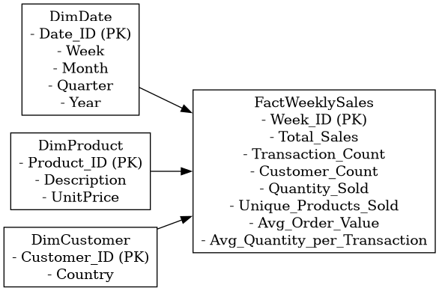
Fig 3.5.1 Data Warehouse Schema

3.6 Feature Engineering
Once the dataset has been fully cleaned and prepared, it must be transformed into a set of features that the machine learning models can effectively utilize. This transformation may involve deriving additional variables from the existing dataset or restructuring the data into formats that better represent underlying patterns relevant to prediction.[32] Feature engineering is therefore essential in converting raw structured data into meaningful representations that enhance model performance.
Given the time-series nature of weekly sales forecasting, several features were engineered to capture temporal dependencies and sales dynamics. Lag-based features were generated to represent historical sales values from previous weeks. For example, Lag_1 reflects sales from the most recent preceding week, while Lag_2 and Lag_3 correspond to sales two and three weeks prior, respectively. These features enable the model to learn sequential patterns and short-term fluctuations in demand.
To capture broader trends, rolling statistical features were also constructed. Rolling means were calculated by averaging sales across a specified number of previous weeks, providing a smoothed representation of medium-term sales behavior. The rolling mean for a window of N weeks is expressed as:
$${Rolling Mean}_{N}=\frac{1}{N}\sum_{i=1}^{N}{{Sales}_{t-i}}$$
These features help the model recognize seasonal tendencies, momentum effects, and cyclical variations that single-week values may not adequately reflect. Other rolling statistics, such as rolling minimums, maximums, and standard deviations, may also be derived to characterize volatility, though only the most relevant features were retained to avoid overfitting.
Through this process of feature construction and transformation, the dataset is reshaped into a more expressive and informative form. The engineered features provide the machine learning algorithms with richer contextual signals, ultimately improving the accuracy and reliability of weekly sales predictions.

3.7 Machine Learning Model Development
After the feature engineering stage, an appropriate machine learning algorithm must be selected to build the predictive model. [32] Several algorithms are suitable for sales forecasting, each with different strengths depending on the structure and complexity of the data. Once the algorithm is chosen, the model is trained using the prepared dataset. [32] During training, the engineered features are supplied to the algorithm, enabling it to learn the relationship between these inputs and the corresponding weekly sales values.
In this study, three algorithms were implemented:
Linear Regression, which models the relationship between features and sales through a linear function. [31]
Random Forest, an ensemble-based method that improves prediction stability by combining multiple decision trees. [28]
XGBoost, a gradient-boosting technique optimized for high predictive accuracy and efficient learning. [29]
These models were selected because they are widely used in regression and time-series forecasting tasks and provide a suitable balance between interpretability and predictive performance.

3.8 Model Training Procedure
The dataset was split into training and testing sets using an 80:20 ratio, with the split performed chronologically to maintain the natural order of the time-series data and prevent leakage. Each selected algorithm was then trained on the training set, where the engineered features were used as inputs and the weekly sales values served as targets. This allowed the models to learn the relationships between the features and the sales outcomes before being evaluated on unseen data.

3.9 Model Evaluation Metrics
The performance of each model was assessed using three standard regression metrics: Mean Absolute Error (MAE), Root Mean Squared Error (RMSE), and R-squared (R²). MAE measures the average magnitude of prediction errors, while RMSE penalizes larger errors more heavily and provides an indication of overall prediction accuracy. R² evaluates the proportion of variance in the sales data explained by the model. Together, these metrics offer a balanced assessment of error magnitude, stability, and explanatory power.

3.10 Dashboard Integration
The predictions generated by the trained machine learning models were exported into a structured dataset and integrated into a Streamlit-based dashboard. The dashboard visualizes both actual and predicted weekly sales, enabling side-by-side comparison of model outputs. This visualization supports intuitive interpretation of forecasting performance and provides a practical interface for data-driven decision-making.

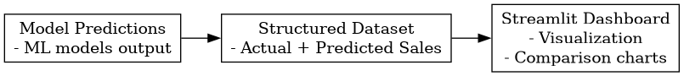
Fig 3.10. 1 Dashboard Workflow

3.11 Tools and Technologies
The system was implemented using the Python programming language, selected for its robust ecosystem supporting data processing, machine learning, and visualization tasks. The Pandas library facilitated data cleaning and structuring, while Scikit-learn provided the core functions for model development and performance assessment. XGBoost was employed to implement gradient-boosted decision tree models, and Matplotlib was used to create exploratory and analytical visualizations. For deployment and interactive presentation of results, the Streamlit framework was utilized to develop a dashboard capable of displaying actual and predicted sales in real time. All components of the system were developed and managed within the Visual Studio Code environment, which served as the integrated development platform.

3.12 Summary
This chapter presented the methodology used to develop the weekly sales prediction system, detailing each stage from data preparation to model deployment. The approach integrated business intelligence principles, an ETL process, and a star-schema data warehouse to ensure a structured and reliable analytical foundation. Feature engineering techniques were applied to capture temporal sales patterns, followed by the development and training of multiple machine learning models using the prepared dataset. Model performance was evaluated using standard regression metrics, and the final predictions were incorporated into an interactive Streamlit dashboard to support visualization and decision-making. Together, these methodological components establish a coherent framework for generating accurate and actionable sales forecasts.

CHAPTER IV

RESULTS

4.1 Weekly Sales Trend
This line chart illustrates the weekly aggregated sales performance across the year 2011. The x-axis represents the months from January to December, while the y-axis displays the actual sales values in monetary units. The visualization captures significant fluctuations in sales activity throughout the year.
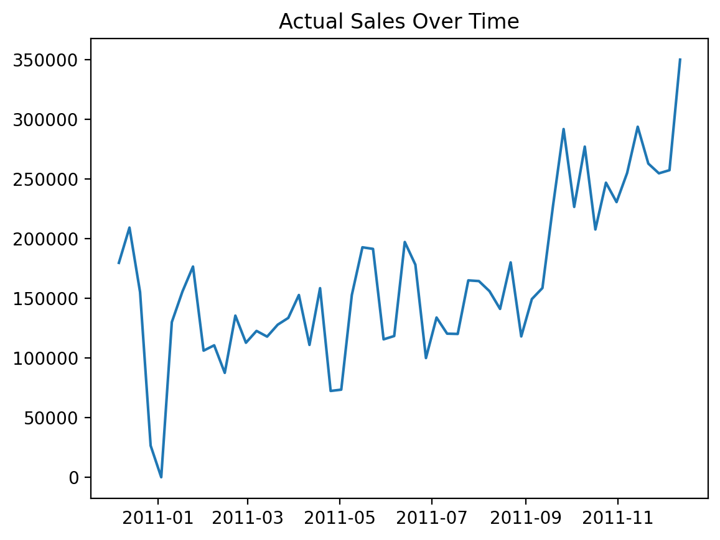
Figure 4.1.1: Actual Sales Over Time (Weekly Aggregated)

4.2 Linear Regression Model Performance
This figure presents a comparative analysis between actual sales values and predictions generated by the Linear Regression model over a multi-year period. The data is displayed as a time series, allowing for visual assessment of the model's forecasting accuracy and consistency.
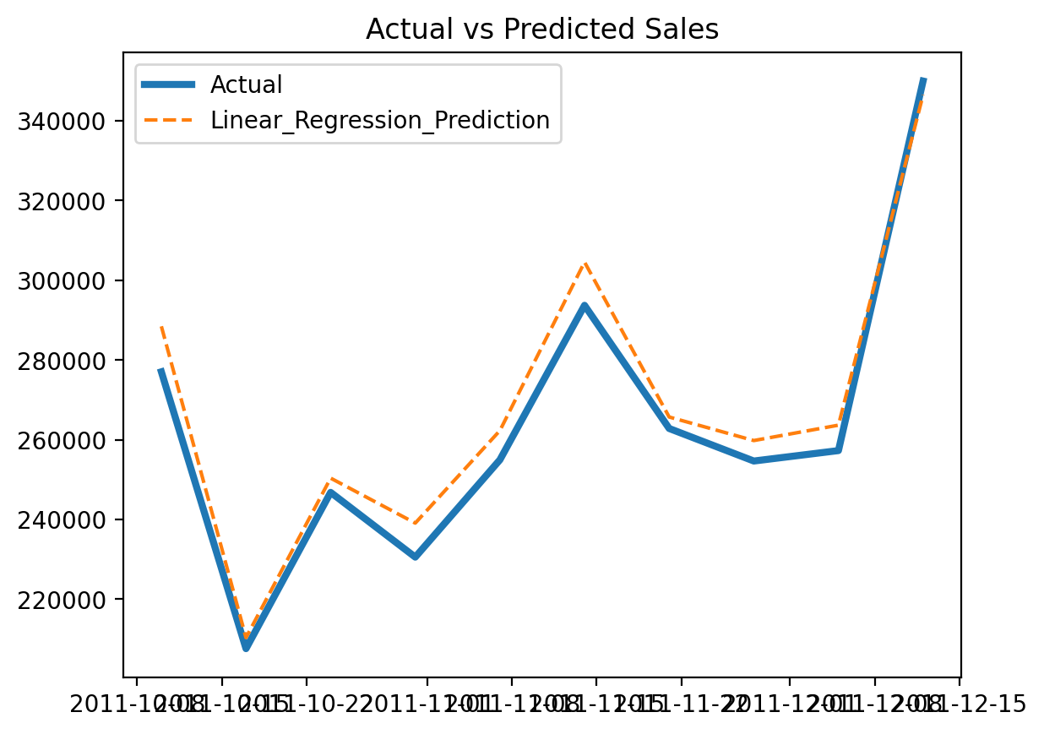
Figure 4.2.1: Actual vs. Linear Regression Predicted Sales

4.3 Random Forest Model Performance
This figure presents a comparative analysis between actual sales values and predictions generated by the Random Forest model over a multi-year period. The time series visualization enables assessment of the model's ability to capture non-linear patterns, seasonality, and abrupt changes in sales behavior.
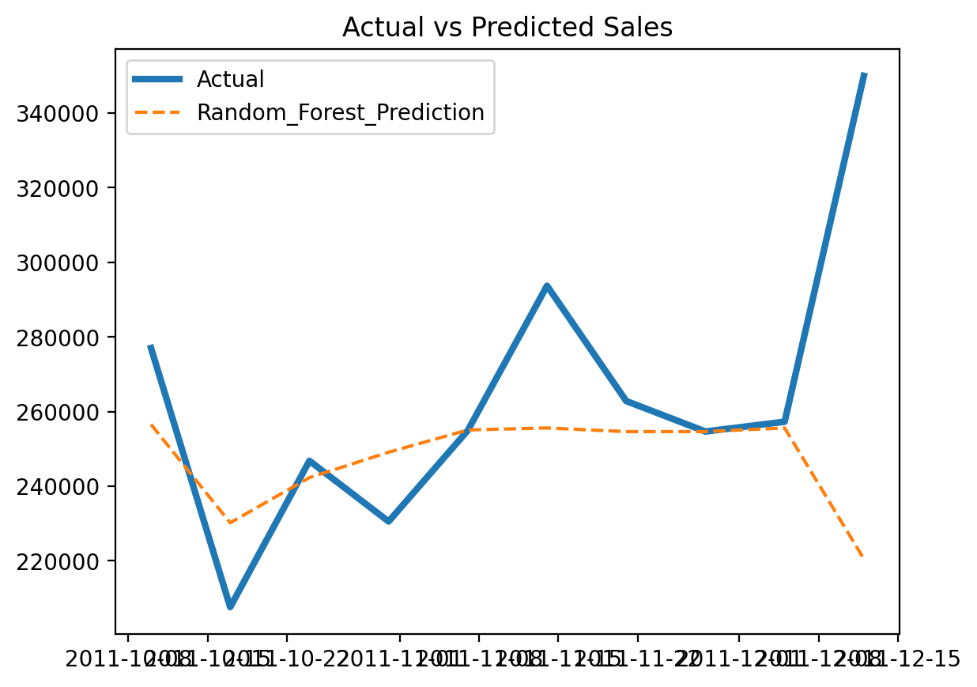
Figure 4.3.1: Actual vs. Random Forest Predicted Sales

4.4 XGBoost Model Performance
This figure presents a comparative analysis between actual sales values and predictions generated by the XGBoost (Extreme Gradient Boosting) model over a multi-year period. The time series visualization reveals critical insights into the model's predictive behavior, stability patterns, and limitations.
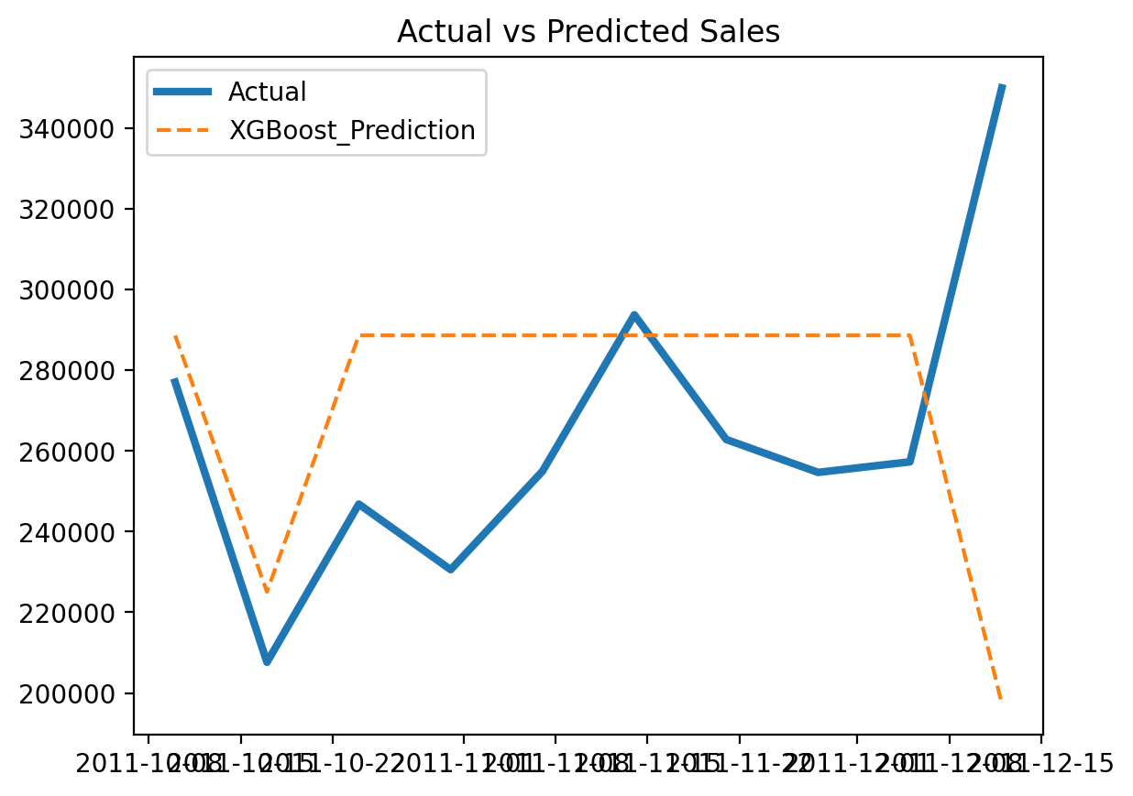
Figure 4.4.1: Actual vs. XGBoost Predicted Sales

4.5 Model Performance Comparison
Invoice Date | Actual Sales | Linear Regression | Random Forest | XGBoost
2011-10-10 | 277034 | 288445.3 | 256560.8 | 288610.44
2011-10-17 | 207614.8 | 210366 | 230222.4 | 225070.02
2011-10-24 | 246804.8 | 250376.1 | 242303.8 | 288610.44
2011-10-31 | 230565.8 | 239097.1 | 249119.7 | 288610.44
2011-11-07 | 254969.9 | 262301 | 255078.4 | 288610.44
Table 4.5.1: Model Performance Comparison – Actual vs. Predicted Sales

4.6 Interpretation
Linear Regression provided the most consistent and interpretable results, making it suitable for high-level trend forecasting.
Random Forest showed potential for capturing complex patterns but requires further tuning to reduce prediction variance.
XGBoost underperformed in this setup, likely due to insufficient feature engineering or improper parameter configuration.

CHAPTER V

CONCLUSION

5.1 Future Work
There are several ways this project can be improved and extended in the future.

A natural next step would be to implement true future forecasting, where the system predicts upcoming weekly sales beyond the available dataset. This would make the model more useful for real-world business planning.

The model could also be enhanced by experimenting with more advanced time-series techniques such as ARIMA or deep learning models like LSTM. These approaches may capture complex patterns that traditional models might miss.

Another important improvement would be to include additional features, such as holiday periods, promotional campaigns, or seasonal effects. These factors often play a major role in sales performance and could further improve prediction accuracy.

On the visualization side, the dashboard can be made more interactive by adding filters, forecasting views, and possibly deploying it online so it can be accessed remotely.

Finally, the system could be scaled to handle real-time data, allowing businesses to continuously update predictions as new data becomes available.

5.1 Conclusion
This study set out to develop a practical and data-driven approach for predicting weekly sales using a combination of data warehousing, machine learning, and business intelligence tools. Starting from raw transactional data, a structured process was followed to clean, transform, and organize the data into a form that could be effectively analyzed and modeled. One of the key strengths of this work lies in the way the data was prepared. By designing a proper ETL pipeline and creating meaningful features such as transaction count, customer count, and average order value, the dataset became much more informative. This step proved to be very important, as it directly influenced how well the models performed.

Three machine learning models were tested: Linear Regression, Random Forest, and XGBoost. Among these, Linear Regression clearly performed the best, achieving a very high R² score of 0.9819. This result shows that the relationship between the selected features and weekly sales is largely linear. While more complex models like Random Forest and XGBoost are powerful, they did not perform as well in this case, which highlights an important lesson: simpler models can sometimes be more effective when the data structure supports them. In addition to model development, a dashboard was created using Streamlit to visualize the results. This made it easier to interpret the data and compare actual sales with predicted values. The dashboard adds practical value to the system by making the results accessible and easy to understand, even for non-technical users.

Overall, this study demonstrates that combining good data preparation, appropriate feature engineering, and the right choice of model can lead to highly accurate sales predictions. It also shows how integrating these components into a single system can support better decision-making in a business environment.

References
- Turban, E., Sharda, R., & Delen, D. (2011). Decision support and business intelligence systems. Pearson Education India.
- Chen, H., Chiang, R. H., & Storey, V. C. (2012). Business intelligence and analytics: From big data to big impact. MIS Quarterly, 1165-1188.
- G. E. P. Box, G. M. Jenkins, G. C. Reinsel, and G. M. Ljung, Time Series Analysis: Forecasting and Control, 5th ed. Hoboken, NJ, USA: Wiley, 2015.
- R. J. Hyndman and G. Athanasopoulos, Forecasting: Principles and Practice, 3rd ed. Melbourne, VIC, Australia: OTexts, 2021.
- S. Makridakis, E. Spiliotis, and V. Assimakopoulos, "The M4 Competition: Results, findings, conclusion and way forward," International Journal of Forecasting, vol. 34, no. 4, pp. 802–808, Oct. 2018.
- L. Chen and C. Chen, "Customer behavior analysis and sales forecasting based on big data," Journal of Physics: Conference Series, vol. 1631, no. 1, p. 012123, Sep. 2020.
- B. Pavlyshenko, "Machine learning models for sales forecasting in e-commerce," in Proc. IEEE International Conference on Data Science and Advanced Analytics (DSAA), Washington, DC, USA, 2019, pp. 399–406.
- T. Chen and C. Guestrin, "XGBoost: A scalable tree boosting system," in Proc. 22nd ACM SIGKDD International Conference on Knowledge Discovery and Data Mining, San Francisco, CA, USA, 2016, pp. 785–794.
- G. Ke, Q. Meng, T. Finley, T. Wang, W. Chen, W. Ma, Q. Ye, and T.-Y. Liu, "LightGBM: A highly efficient gradient boosting decision tree," in Advances in Neural Information Processing Systems, vol. 30, Long Beach, CA, USA, 2017, pp. 3146–3154.
- S. S. R. K. T. V. S. Kiran, "Deep learning model for sales forecasting in e-commerce," International Journal of Engineering Research & Technology, vol. 10, no. 4, pp. 138–143, Apr. 2021.
- A. Vaswani, N. Shazeer, N. Parmar, J. Uszkoreit, L. Jones, A. N. Gomez, L. Kaiser, and I. Polosukhin, "Attention is all you need," in Advances in Neural Information Processing Systems, vol. 30, Long Beach, CA, USA, 2017, pp. 5998–6008.
- H. Wu, J. Xu, J. Wang, and M. Long, "Autoformer: Decomposition transformers with auto-correlation for long-term series forecasting," in Advances in Neural Information Processing Systems, vol. 34, Virtual Event, 2021, pp. 22419–22430.
- G. Bontempi, S. Ben Taieb, and Y.-A. Le Borgne, "Machine learning strategies for time series forecasting," in Business Intelligence: Second European Summer School, M.-A. Aufaure and E. Zimányi, Eds. Berlin, Germany: Springer, 2013, pp. 62–77.
- K. Bandara, C. Bergmeir, and S. Smyl, "Forecasting across time series databases using recurrent neural networks on groups of similar series: A clustering approach," Expert Systems with Applications, vol. 140, p. 112896, Feb. 2020.
- R. Kimball and M. Ross, The Data Warehouse Toolkit: The Definitive Guide to Dimensional Modeling, 3rd ed. Indianapolis, IN, USA: Wiley, 2013.
- M. Golfarelli and S. Rizzi, Data Warehouse Design: Modern Principles and Methodologies. New York, NY, USA: McGraw-Hill, 2009.
- S. Few, Information Dashboard Design: Displaying Data for At-a-Glance Monitoring, 2nd ed. Burlingame, CA, USA: Analytics Press, 2013.
- A. Popović, R. Hackney, and R. Tassabehji, "Business intelligence and analytics: A systematic literature review," Information Systems Frontiers, vol. 20, no. 6, pp. 1215–1228, Dec. 2018.
- M. Zaharia, R. S. Xin, P. Wendell, T. Das, M. Armbrust, A. Dave, X. Meng, J. Rosen, S. Venkataraman, M. J. Franklin, A. Ghodsi, J. Gonzalez, S. Shenker, and I. Stoica, "Apache Spark: A unified engine for big data processing," Communications of the ACM, vol. 59, no. 11, pp. 56–65, Oct. 2016.
- A. Barredo Arrieta, N. Díaz-Rodríguez, J. Del Ser, A. Bennetot, S. Tabik, A. Barbado, S. Garcia, S. Gil-Lopez, D. Molina, R. Benjamins, R. Chatila, and F. Herrera, "Explainable artificial intelligence (XAI): Concepts, taxonomies, opportunities and challenges toward responsible AI," Information Fusion, vol. 58, pp. 82–115, Jun. 2020.
- S. M. Lundberg and S.-I. Lee, "A unified approach to interpreting model predictions," in Advances in Neural Information Processing Systems, vol. 30, Long Beach, CA, USA, 2017, pp. 4765–4774.
- D. Sculley, G. Holt, D. Golovin, E. Davydov, T. Phillips, D. Ebner, V. Chaudhary, M. Young, J.-F. Crespo, and D. Dennison, "Hidden technical debt in machine learning systems," in Advances in Neural Information Processing Systems, vol. 28, Montreal, QC, Canada, 2015, pp. 2503–2511.
- D. Kreuzberger, N. Kühl, and S. Hirschl, "Machine learning operations (MLOps): Overview, definition, and architecture," IEEE Access, vol. 11, pp. 31866–31879, Mar. 2023.
- G. S. Dawson, "Marketing mix modeling and machine learning: A hybrid approach," Journal of Marketing Analytics, vol. 8, no. 3, pp. 147–158, Sep. 2020.
- S. Makridakis, E. Spiliotis, and V. Assimakopoulos, "Statistical and machine learning forecasting methods: Concerns and ways forward," PLoS ONE, vol. 13, no. 3, p. e0194889, Mar. 2018.
- S. Chopra and P. Meindl, Supply Chain Management: Strategy, Planning, and Operation, 7th ed. London, UK: Pearson, 2019.
- T. Boone, R. Ganeshan, and R. L. Stading, "Forecasting and inventory management for e-commerce: A case study," Journal of Business Logistics, vol. 40, no. 4, pp. 279–291, Dec. 2019.
- L. Breiman, “Random forests,” Machine Learning, vol. 45, no. 1, pp. 5–32, 2001, doi: 10.1023/A:1010933404324.
- T. Chen and C. Guestrin, “XGBoost: A scalable tree boosting system,” in Proc. 22nd ACM SIGKDD Int. Conf. Knowledge Discovery and Data Mining (KDD), 2016, pp. 785–794, doi: 10.1145/2939672.2939785.
- R. Kimball and M. Ross, The Data Warehouse Toolkit: The Definitive Guide to Dimensional Modeling, 3rd ed. Hoboken, NJ, USA: John Wiley & Sons, 2013.
- F. Pedregosa et al., “Scikit-learn: Machine learning in Python,” Journal of Machine Learning Research, vol. 12, pp. 2825–2830, 2011.
- V. Suryawanshi, M. Venkatesan, S. Chate, S. Amane, A. Bhondekar, and F. Mulani, “Sales forecast prediction using machine learning,” in 2024 Intelligent Systems and Machine Learning Conf. (ISML), 2024, pp. 745–750, doi: 10.1109/ISML60050.2024.11007449.
- M. D. Tamang, V. K. Shukla, S. Anwar, and R. Punhani, “Improving business intelligence through machine learning algorithms,” in 2021 2nd Int. Conf. Intelligent Engineering and Management (ICIEM), 2021, pp. 63–68, doi: 10.1109/ICIEM51511.2021.9445344.

